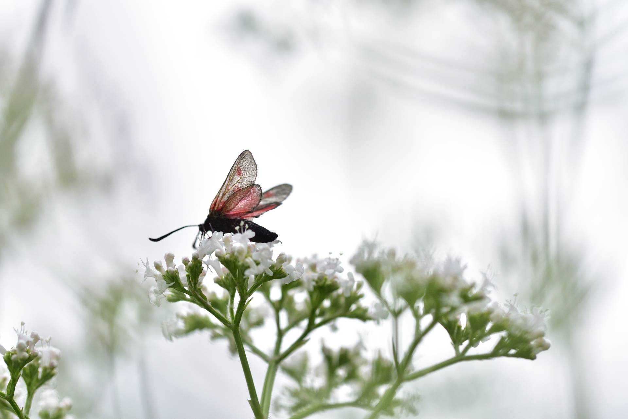

Regression on House Dataset

By Salih Eren Yüzbaşıoğlu

AI Club AR-GE

|  |
| --- |
| Regression explanation |

Regression is a statistical technique used to find the relation between one dependent variable and one or more other independent variables.

|  |
| --- |
| The history and culture of Butterflies |

* Want to insert a picture from your files or add a shape, text box, or table? You got it! On the Insert tab of the ribbon, just tap the option you need.
* Think a document that looks this good has to be difficult to format? Think again! To easily apply any text formatting you see in this document with just a tap, on the Home tab of the ribbon, check out Styles.
* Some of the sample text in this document indicates the name of the style applied, so that you can easily apply the same formatting again. For example, this is the List Bullet style.

|  |
| --- |
| Pollinator health |

Need to add a table of contents or a bibliography? No sweat.

|  |  |  |
| --- | --- | --- |
| Add a Table of Contents |  | Add a Bibliography |
| It couldn’t be easier to add a table of contents to your report. Just click on the document where you want the TOC to appear. Then, on the References tab, click Table of Contents and then click one of the Automatic options.  When you do, the TOC is inserted and text you formatted using Heading 1, Heading 2, and Heading 3 styles is automatically added to it. | On the References tab, in the Citations & Bibliography group, click Insert Citation for the option to add sources and then place citations in the document.  When you’ve added all the citations you need for your report, on the References tab, click Bibliography to insert a formatted bibliography in your choice of styles.  And you’re done. Nice work! |